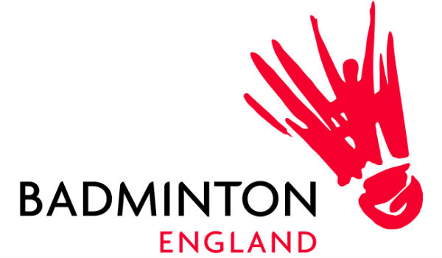

Badminton England

Player Request Form
[Give the name of your event / activity]

Contact
Contact: [Your name & title]
Email: [your email address]
Tel: [your number]
Mobile: [your number – mobile]

Key information

Date | e.g. what day and date the event / activity is
Time | e.g. what time you want them to arrive and what time the event / activities begin, plus when it’s likely to be finished
Location | e.g. where the event / activity is taking place plus any relevant info like where to park, what building to look for etc
Dress code | e.g. what do you want them to wear for the event / appearance – in most cases this will be the Team England kit and tracksuit
Equipment required | e.g. do you need them to bring a racket? Will they be playing at any point?
Contacts | e.g. who they should call on the day if they have any problems or questions

Event / activity overview
This is where you should provide details of background for the event / activity e.g. what is it? Why is it happening? Why is the player there – for example to meet participants / talk to the media / etc

Use this space to provide any key stats or info you would like the player to know, and to mention in interviews etc. For example over 15,000 children took part in the Center Parcs National Schools Championships.

- Key facts & background…

Outline of event / activity format
This is where you should let the player know the basic format of the activities with a rough timeline.

e.g.
10am Player to arrive on site
10.15am Player briefing with…
10.30am Autograph signing session
11am Meet the media (interviews TBC)
12noon Present medals
1pm Expected departure

You should explain all elements of the event / activity e.g. The medal presentation ceremony will last approximately 15mins. Medals will be awarded to the teams coming first, second and third in the competition. The presentation party will comprise of the player and the Chairman of the County Badminton Association. etc

Expenses
Travel expenses will need to be covered by the requesting team. This should be taken into account when planning your activity. Here you should let the player know of any code or special processes that they have to use when submitting their expenses claims form.

Media
This section helps prepare the players for any interviews / quotes / comments they may be asked for.

Let them know about any confirmed media, any you are waiting for a response from, or if there will be no media present at all.

About Badminton England:
As the National Governing Body we are the organisation for all things badminton in England for everyone who wants to get involved whatever age, ability or gender.

We love playing, watching and supporting badminton. We want everyone in England to do the same and become part of the badminton community, whether as a player, coach, volunteer or fan.

With Olympic success at the heart of our ambitions, we are investing our knowledge and expertise to build a quality future for our sport by strengthening and evolving the domestic game and developing talent to achieve success on the international stage, inspiring the next generation of players and fans.

We aspire for our sport to be seen globally for the skill, speed and dynamism our players exhibit; and the passion, excitement and dramatic atmosphere our fans feel and create when supporting badminton’s superstars.

With millions playing every year, badminton is the nation’s favourite racket sport. We want to inspire everyone to play more, support louder and love badminton, from this generation to the next.

Badminton England was named the National Governing Body of the Year at the BT Sport Industry Awards 2015.

For further media information on Badminton England please contact: media@badmintonengland.co.uk

Please email this completed form to: emmaeveleigh@badmintonengland.co.uk

